**Assignment 4**

Sergio Cutrim Gouveia

Georgian@ILAC

COMP 1112: Document Automation Using Python

Sagara Samarawickrama

August 06, 2024

# Assignment 4

# Instructions

**Question 1**

The first question requires us to create the folders required to create a website via python – static, template and any other subfolders. For the exercise, we will use the website that the teacher created in class as a template so it can be done easier.

My project is named week13Python, and I created a folder inside named Assignment4, inside that folder I created Static and as subfolder CSS and Images (inside each the appropriate files that are going to be used on the website). I have also created the folder Templates that has inside it index the html, and to finish I created the python file named server.py.

Each one of the folders is marked in red in the screenshot below:

**Question 2 and 3**

I am putting the 2 questions as one because I didn’t read both questions and did part 2 without taking the screenshots. The second part only requests to install flask and question 3 requests me to show the installation of flask (step by step). Question 2 was done successfully so I will do it all over again for another project I created from scratch. The idea is just to show how to install flasks.

(from this point on you will see the name of the new project created only to install flask)

First step I am going to check if flask is installed as an interpreter or not by going to Settings > Python Interpreter:

Since it is not installed, we must create the virtual environment in the terminal and activate it using the commands taught in class:

* py -3 -m venv .venv 🡪 this command has to be used to create the virtual environment. It looks in the screen as it is doing nothing and no message comes to the screen it just goes back to the directory already used.
* .venv\Scripts\activate 🡪 after creating the virtual environment now I can activate it and using this command makes the (.venv) becomes green in the beginning of the path.

Now that the foldes is active we can now install the flask using the command: pip install Flask. After running the terminal will display a message as below confirming the installation:

To confirm Flask is running I can go to the Settings again and check the interpreters as it was done in the beginning. It should show now all that was installed.

(now back to the project that has the assignment)

**Question 4 to 9**

From now on all the questions are about the development of the website, so I will treat all together as one question and detail each part of html and css.

HEADER in HTML

In the header I included the title as the name of the page that appears on the top of the browser, I also added a CSS link to connect to my CSS folder and a font from google just to test if the connections were working and to make the website a little bit more attractive.

As it should be when I opened the page the title appeared perfectly.

HEADER

Now I started the body of the HTML with the Header. The header will be a large bar with 3 columns (divs). Inside the first column I am going to put a logo, the 2nd will have the name of the website and the 3rd will have a list of Menu to go to any other page of the website. Since this exercise is more about Python I only added one page the Home, but adding new ones is easy just keep using the code <li> and adding more links.

For the header I had to include CSS to make the page stylized. SO lets take it part by part in the CSS file.

Adjust the external DIV that contains all the DIVs, and also the DIV that contains the LOGO:

Adjust the image to be rounded and add some features to the image to adjust it to the logo div:

Adjust the title of the page to be centralized vertically but arranged as aligned to the left, also changing the font:

Adjusting the menu via CSS:

After applying all the css I can now see it on the webpage:

The color of the background is set as the background of the main div that is why it is applied to all the headers. The letter I changed just to test if the connection with google fonts was possible. The logo was created as I wanted and centered in a small box on the left, and finally the links and the name are displayed as I wanted.

I will skip for now the main and go to the FOOTER since it has a similar design.

FOOTER

The CSS and HTML are not the main focus, and because of that I will start to go a little bit faster on this part. This is the footers HTML

Basically it is the same as the header with 3 DIVS inside a bigger div. The diffference is in the CSS that I made to have the information on the footre centered instead of align to the left. Also the links now are static images of social media, all the links are working and I have added a link to all of them.

The CSS of the footer is below:

As I wanted the page is behaving and showing the texts and colors I defined.

Now let me go finally to the main page, the concept is the same, I have added 3 columns one picture, one with links and one with a brief description about me. Simple page just to show how it works.

The CSS is below:

Finally the main part of the page looks like this:

Now let me show the Py file that connects all of this and brings the site to be online:

This code is basically the same one we have been using in class. First we import the flask, render and send from directory to bring the main function, the function that renders the html and the last one that serves files from the directory. After that we import os to handle paths.

We initialize the flask with the following part: app = Flask(__name__), then we define a route that handles the static files – DEF STATIC FILES.

Finally we print the name (__name__) and run the app. Once we hit play in this py file the terminal will open up and send us a message with the link and all you have to do is to click there to open the webpage:

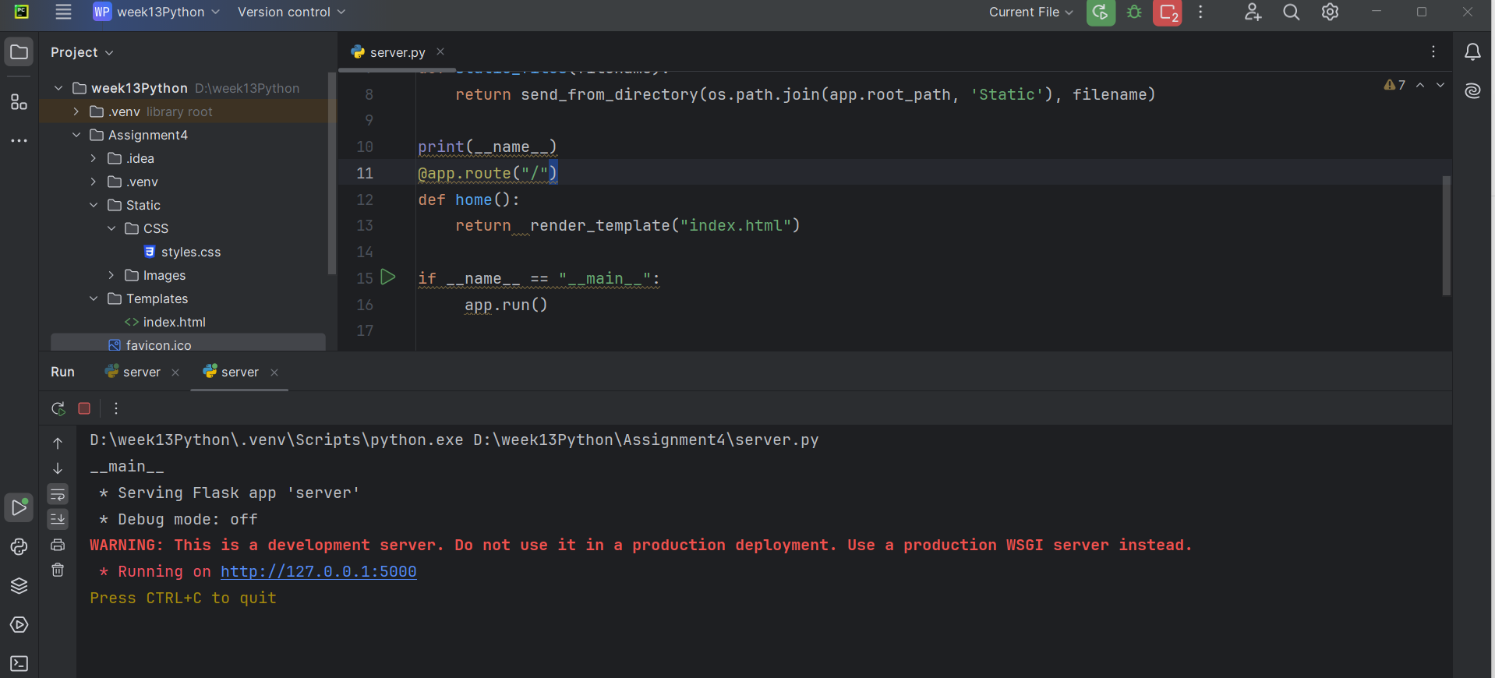

By clicking in the link it opens this:

